-RESEARCHING IDLE GAMES-

Empires and Puzzles: RPG Quest

Empires and Puzzles is a twist on the widely-used match three mechanic in that it focuses on RPG systems. As with some of the other games I’ll be investigating, heroes are one of the main areas of focus in Empires and Puzzles and having a strong team of them is the key to progressing. Players are provided with a team of heroes that are used to fight enemies through a match three style of gameplay. By matching gems of the corresponding colour, each hero gains power towards a special skill that can be used to damage the enemy. By clearing stages of combat, players can earn resources and crafting materials, as well as new heroes/troops. These can be used to upgrade buildings in the player’s base or used towards levelling up a player’s hero. Player’s can also earn resources by creating and upgrading buildings in their base. For example, a mine will generate Iron over time. Player’s can either wait a set amount of time for a building to be complete or pay a number of gems to skip the wait time. By upgrading their stronghold players can expand their base, making room for additional buildings.

By “training” a hero with others, the player must sacrifice some of their troops for the purpose of levelling up and doing so enough times will allow the hero to be ascended. Depending on the rarity of the hero, they may either be ascended once or multiple times.

**Mechanics. Dynamics and Aesthetics**

* Matching
* Strategy; planning moves during match-three gameplay to optimise damage output according to the combat triangle etc.

**Gating and Progression**

**Reward Schedules (Contingencies)  
Further info about what these mean** [**here**](https://www.gamasutra.com/blogs/WilliamWang/20170329/294691/Reward_Schedules_and_When_to_Use_Them.php) **or** [**here**](http://www.educateautism.com/applied-behaviour-analysis/schedules-of-reinforcement.html)

* Fixed ratio schedule
  + The player earns resources every time they complete a battle
* Fixed interval schedule
  + The player earns heroes or troops after completing battles every so often
* Variable ratio schedule
* Variable interval schedule

**Hedonic (relating to pleasant sensations) attributes**

* Sound effects when levelling up troops, accompanied by an animation
* Sound effect and reward overview screen when levelling up
* Background story of elemental stones and the Dark Lord

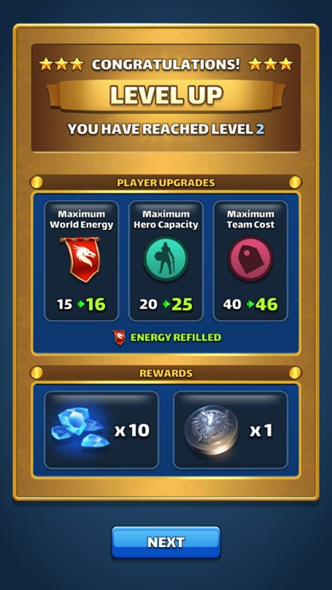

**Layered pricing; virtual currencies and real-world cost**

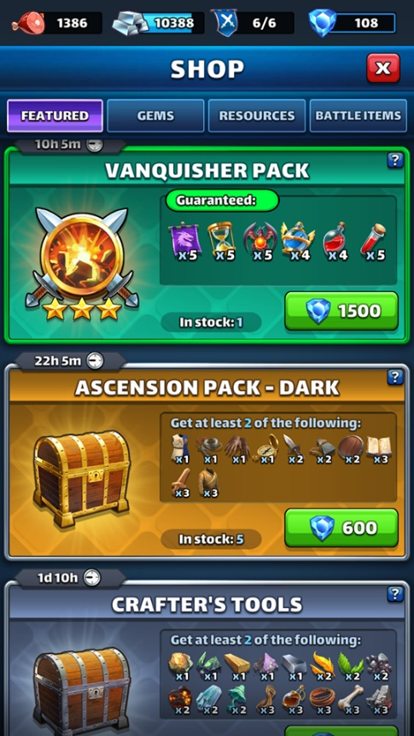

**Pros**

* Background parallax according to phone gyroscope

**Cons**

* Tutorial went on too long just to demonstrate a single mechanic e.g. unable to play match 3 part of the game without constant prompts
* Too much text
* Holds player’s hand too much rather than teaching them the basics and letting them play the game
  + In some cases, I found myself getting frustrated as I was forced to make suboptimal moves during the match 3 part of the game, when I could see matches of 5 or more

Idle Heroes

CosmosQuest

Animal Crossing: Pocket Camp

* Camp and character customisation
* Social; can give your friends kudos or help them during events by sharing rewards and watering plants
* The villagers have their own personalities
* Gather crafting resources by helping villagers who change over every 3 hours
* Wait time for items to be crafted (varies between objects), player can choose to create an item instantly by paying with leaf tickets
* Log-in bonus encourages player to visit the game at least once a day
* Limited time events to get exclusive furniture for your camp
* The game itself requires no skill
* Daily goals and stretch goals